

Welcome to
St Margaret Clitherow
Catholic Voluntary Academy
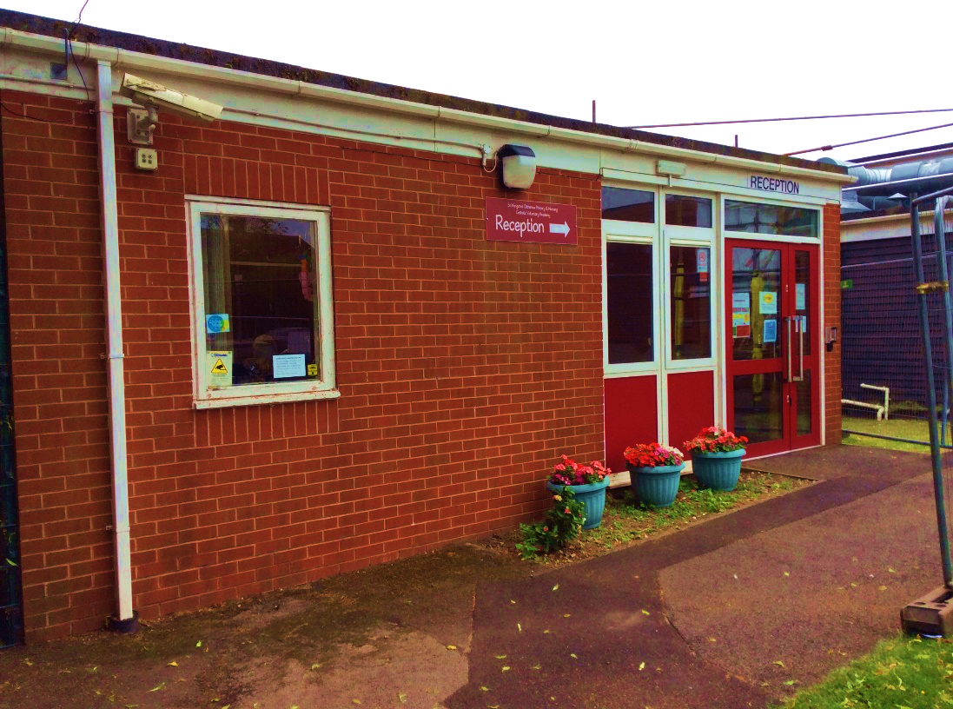

Information Pack for F2 Parents
“Love One Another as I have Love You”
John 13:34-35

Headteacher’s Welcome
Mrs Sweeney-McGinty

Designated Safeguarding Lead

On behalf of all of the children, staff, and governors, I would like to warmly welcome you to St. Margaret Clitherow Catholic Voluntary Academy.
​​At St. Margaret’s we believe that every child is special and that ‘the child is at the centre of everything we do.’ At the heart of our school is our Catholic faith and we strive to ensure that the children develop spiritually and morally as well as academically, physically, socially and creatively.
​We strive to be a place where children are happy and enjoy their learning in a safe and secure environment. We are committed to developing the talents and skills of every child to enable them to achieve the best that they can. We also wish to nurture their spiritual and personal development so that they will grow in their understanding of our mission statement, ‘Love one another as I have loved you’ (John 13:34-35) and become caring and responsible citizens.
I know that starting school is an important milestone for you and your child. I hope this booklet will provide you with all the information you need to ensure the move to school goes smoothly. If you do have any queries, please contact our school office in the first instance and one of the team will get back to you.
I am looking forward to meeting you all.
​Mrs Sweeney-McGinty
Headteacher

School Contact Details
St Margaret Clitherow Primary and Nursery Catholic Voluntary Academy
Mildenhall Crescent
Bestwood Park
Nottingham
NG5 5RS
Telephone Number - (0115) 915 0296
Email address - admin@st-margaretclitherow.nottingham.sch.uk
School Website - https://www.st-margaretclitherow.nottingham.sch.uk/

Meet the Team
It is our belief that all children in our care should aim to reach their full potential whilst learning in a safe, stimulating and happy environment. Our aim is to build on what the children already know, offering them a wide range of quality activities to extend their learning, together with experienced and committed practitioners who have a sound understanding about how children learn.
 |  | 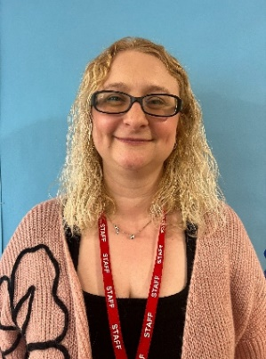 | 
Mrs Ogunlade  Class Teacher | Mrs Waszkiewicz  Teaching Assistant | Miss Mark  Teaching Assistant | Miss McCall  Teaching Assistant

The School Day
School starts at 8:45am
At the start of the day, you should line your child up with their class on the main playground. Teaching staff will come and meet you and your child on the playground. The class teachers will take their class into school at 8:45. Parents should say goodbye to their children on the playground.
Any children arriving after this time should be taken to the school office and signed in.
Your child will be starting school at 9:30am on the following days:
Wednesday 3rd September 2025
Thursday 4th September 2025
Friday 5th September 2025
From Monday 8th September your child will be starting school at 8:45am.

School ends at 3:15pm

At the end of the day, please walk through the green gate next to the school office, and line up to collect your child from the small brown gate. The class teacher will bring the children to the brown gate and dismiss them. If someone different is collecting your child, please let us know in advance.

The school day is a busy one and will be similar to the example below.
8.45 - Children line up with their class and are taken into school by teachers.
8:55 - 9:00 Register is taken.
9.00 – Guided Reading
9.20 - English/Maths and Continuous Provision activities.
10.00 - Playtime
10.15 - Phonics and Continuous Provision activities
11.30 - Lunchtime
12.30 - Register and Maths
1:10 – Topic/RE and Continuous Provision activities.
3.00 - Story Time
3.15 - Home Time

We will have class PE sessions once a week on a Thursday.

Absences
If your child is too poorly to attend school, please telephone the office on the first day of their absence, advising us on the reason for the absence. If your child has sickness and/or diarrhoea, they must be clear of symptoms for 48 hours before returning to school.

School Dinners
School dinners are free of charge until the end of Year Two. School meals are provided by Aspens and are cooked on the premises. The children will choose from a varied selection taken from a three-week menu cycle of hot meal choices, sandwiches and filled jacket potatoes. Please see the menu in your welcome pack. Please help your child choose BEFORE they come to school what they would like so they can tell their teacher.
If you would like your child to bring a packed lunch, please provide a healthy lunch and ensure that the lunch-box is clearly labelled with their name. Please be aware that St Margaret Clitherow is a NUT FREE ZONE.
When children have finished eating their lunch, they will walk from the dinner hall to the playground where they will have time to run around and play before lunch time ends at 12.30 when they will return to their classrooms for the start of the afternoon session.
Fruit and Milk
All children will receive a free carton of milk each day until the term of their 5th birthday. After this, milk can be purchased at a small cost. You will need to apply online to receive this milk. Please see leaflet ‘Why Milk is Great’. All children will also get a piece of fruit each day up until Year 2, free of charge. A selection of fruit is offered throughout the week and children can access this from the snack table whenever they feel hungry during continuous provision time.
Biscuits
We also offer the children a biscuit at snack time at a small cost. Please see attached letter about biscuits.

Water bottles
In addition to this, your child must bring a bottle of water to school, clearly labelled with their name, which they can access at any time during the day. Fruit juice and fizzy drinks are not allowed.
Baking and Growing
Throughout the year we plan activities to enhance the children’s learning that may need additional resources. We ask for a contribution of £3.00 per term towards the cost of resources.
School Uniform
Wearing a school uniform encourages a sense of belonging for young children. We ask you to encourage your child to wear their uniform with pride.
School uniform is available to purchase from a local supplier Just School Wear. https://just-schoolwear.co.uk/product-category/st-margaret-academy/
We expect all children to wear full school uniform everyday.
- Red jumper or cardigan containing the school logo

- White polo shirt with the school logo
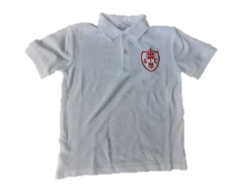
- Dark grey trousers, shorts, skirt or pinafore
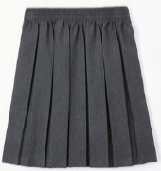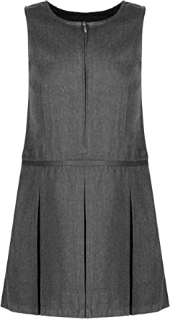
- Red gingham summer dress
- Plain red, black, white or grey tights
- White or grey socks for girls
- Grey socks for boys
- Sensible black shoes, ones with Velcro fastenings are the easiest for young children (not trainers or plimsolls)
- If your child has pierced ears, earrings should be studs only. Earrings should be removed for PE days. No other jewellery is permitted.
- Hair decorations should be minimal.
Please ensure that your child’s name is in all items of clothing. Sometimes items of clothing do go missing and it is a lot easier to find them if they are clearly labelled! Your child will be taking part in lots of interesting and sometimes messy experiences, even though aprons are available they may come home a little dirty!
PE Kit
Your child’s PE day is Tuesday. On this day, we ask that your child comes to school in their PE kit.
- White polo shirt with school logo
- Black shorts or jogging bottoms
- Black hooded top (in cold weather)
- Plain trainers and white socks.
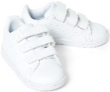
Other Equipment
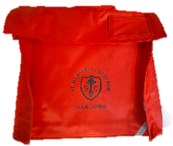
Your child will also need a school book bag. This will be to bring reading books to and from school, as well as any letters or important information. Please ensure these are brought to school every day.
Medical Conditions
To ensure the well-being of all our children please let us know if your child has any medical conditions. Please complete the medical questionnaire and return it to school as soon as possible.
In addition, please ensure that you inform us of any allergies that your child may have. All children must have the ‘Special diets/allergy form’ completed even if they do not have any allergies. This is to ensure that we provide the children with the correct dinners at lunchtime. If a special diet is required, a medical certificate is required outlining all allergies and dietary requirements.
Medication in School
Medicine will only be administered in school if absolutely necessary. Parents will be required to complete a consent form giving all relevant information. The medicine must be in the original prescription bottle, labelled with the child’s name and dosage. Non-prescribed medication is not given by school except in the case of allergy medication.
If your child requires an epi-pen, please provide all relevant medication in a clear box clearly marked with their name. We would also need to complete a health care plan so that we have all relevant details about medication and care of your child.
If your child is asthmatic, please provide a spare inhaler for use in school. This should be in a clear box with your child’s name clearly marked on it. Parents will be required to complete a medical consent form giving all relevant information. Children with asthma will be supported by a first aider to take their inhaler if required.
Toileting
In preparation for starting school, you can help your child become more independent by training them to take care of their own toileting needs. Children will need to be able to pull trousers up and down, wipe themselves after using the toilet and wash their hands independently. Children have free access to the toilets during continuous provision time and staff will remind them to use the toilets at key times in the school day but sometimes accidents do happen. We will always let you know if your child has had an accident. Please let us know if your child has any difficulties with toileting.

Breakfast Club and Wrap Around Care
Our Breakfast Club is run by Mrs Wilson (who is also a Learning Support Assistant). It runs daily from 7.30am until 8.45am, after which time the children are taken to their classroom. The cost of breakfast club is £4 per day. If this is something you are interested in, please contact the school office.
Our after-school care is provided externally by TB Sports. They offer care from Monday-Thursday. The cost of after-school is currently under review.
Please contact the school office if this is something you are interested in.

Local Visits
There may be occasions when your child will take part in local visits. These form part of the curriculum followed by the school. These local visits do not involve any kind of transport. They may include visits to the local church, local park, walk around the local area or shops. Please complete the visits consent form and return it to school. You will always be informed of the activity prior to your child being taken out of school.
We may also go on trips that do require transport. If we do, you will receive a separate consent form to complete for this.
Photographic Consent
As part of your child’s education, we often take photographs and videos to record and celebrate their work. These photographs may be displayed around the school, on the school website and on social media.
There are certain things that we are unable to do without your consent. We have set these out on the ‘Pupil Consent Form’. Please read the form carefully and tick the appropriate options. Further information can be found in The Trust Privacy Notice.
Contact Details
Please fully complete the ‘Pupils Personal Information Form’. This must be returned to school as soon as possible. It extremely important that we have the correct details in case we need to contact you. If any details change, please inform the school office.
On the form, please complete the sections that indicates your child’s ethnic background and first language. From time to time this information will be passed to the Local Authority and the DfE to contribute to local and national statistics. The information will not be published in a way that allows individual children to be identified.
School Communication
The School uses a centralised student information system called ARBOR.
This give you access to the information held on your children. And allows you to make communication with school, review attendance and make payments towards dinners, clubs, trips etc.
Access details for Arbor will be sent out to registered email addresses once your child is admitted to School.
Behaviour and Policies
At St Margaret Clitherow, we want to prepare our children for the life that lies ahead of them and believe that explicit teaching of outstanding behaviour is integral in preparing children for their next stage in education. Through “The St Margaret Clitherow Way”, we teach outstanding behaviour through clear expectations and routines. We have high expectations and believe that every pupil can choose to behave well. We consistently use rewards and praise good behaviour of all children. When a problem arises in this area there is always close consultation with parents and we hope to solve any difficult situations by working together.
Our school rules are based on RESPECT. These are as follows:
- Respect yourself: Wear your school uniform with pride and always try your best.
- Respect each other: Listen to each other; use kind words and keep your hands and feet to yourself.
- Respect adults: Show all adults respect and do as you are asked first time, every time.
- Respect our school: Be grateful; use your manners; care for our resources and keep our school tidy.
- Respect our learning: Listen in class; let others listen and move around the school quietly.
- Respect our future: Be proud. Be ambitious. Be a role model, look after each other and set a good example.
Please read these rules with your child so they are familiar with them.
Various policies and guidelines are available to read or download from the website. Link to the policies page is https://www.st-margaretclitherow.nottingham.sch.uk/information/our-policies/

