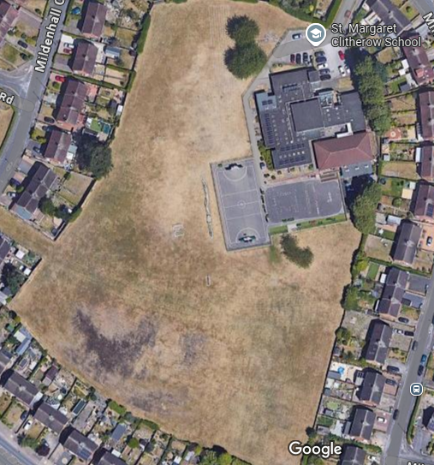
Symbolic play
Football
Bike/scooter
Ball games and Sports
Gravel pit
Reading area
Performance area
Trenches
Mud pit
Mud Kitchen
Prayer area
Nature area
Tree swings
Den building
Sandpit
Climbing and slide

