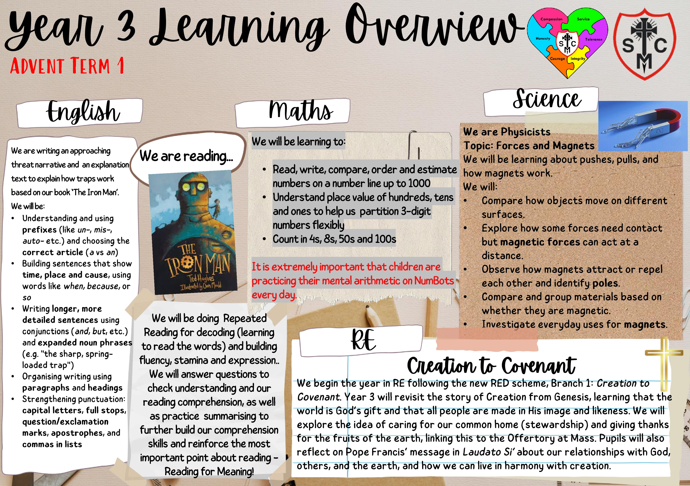
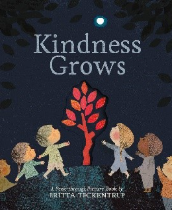
In English, we are focusing on grammar for the first six weeks, so that we have a good foundation for all our written work.
We shall be learning the difference between a common noun and a proper noun.
We shall be learning what the subject of a sentence is and identifying it in a lot of sentences.
We shall be finding verbs in sentences and learning other words that have similar meanings so that our writing is more interesting.

